**Project Development**

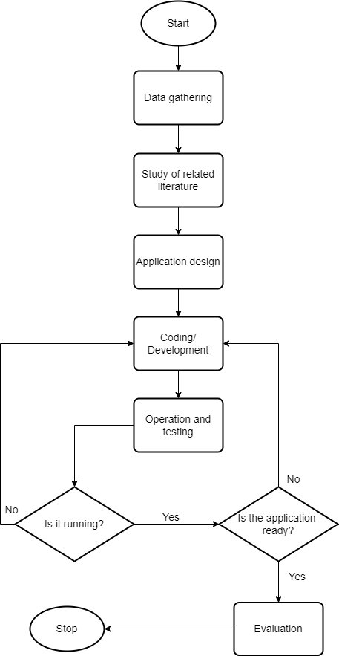This part of the study highlights the comprehensive development of the project. The first part of the research will be data gathering wherein the researchers will collect and analyze the data to understand the manual processes that need to be automated and centralized at the Manila City Hall. Additionally, various tools and technology will be studied by the researchers so that appropriate solutions will be applied to streamline the operations of the said city hall.